SUBMMITTED BY

NEHA ANN VARUGHESE

BTECH CSE

COLLEGE OF ENGINEERING ARANMULA

INTERNSHIP REPORT:

full-stack TODO LIST web APPLICATION

# ABSTRACT

This project is a simple and efficient Todo Application developed using the MERN stack, specifically utilizing React for the frontend and Node.js + Express + MongoDB for the backend. The application allows users to manage their daily tasks through a clean and user-friendly interface.

The React frontend communicates with the backend through Axios HTTP requests. Tasks are stored persistently in MongoDB Atlas, and each task is uniquely identified using its MongoDB- generated `_id`. The backend is powered by Express and uses Mongoose to interact with the database.

# INTRODUCTION

In today’s fast-paced digital world, managing tasks efficiently is essential for productivity and time management. This project, titled "Todo App", is a lightweight and intuitive web-based application that allows users to create, view, and delete tasks with ease. It serves as a basic yet functional demonstration of a CRUD (Create, Read, Delete) application using modern web development tools

The Todo App provides real-time updates to the user interface, ensuring that the task list remains synchronized with the backend. The clean and responsive user interface, built with Tailwind CSS, makes it accessible and easy to use.

# FEATURES

Key features include:

* Adding new tasks
* Viewing all existing tasks
* Deleting individual tasks

# IMPLEMENTATION (CODE)

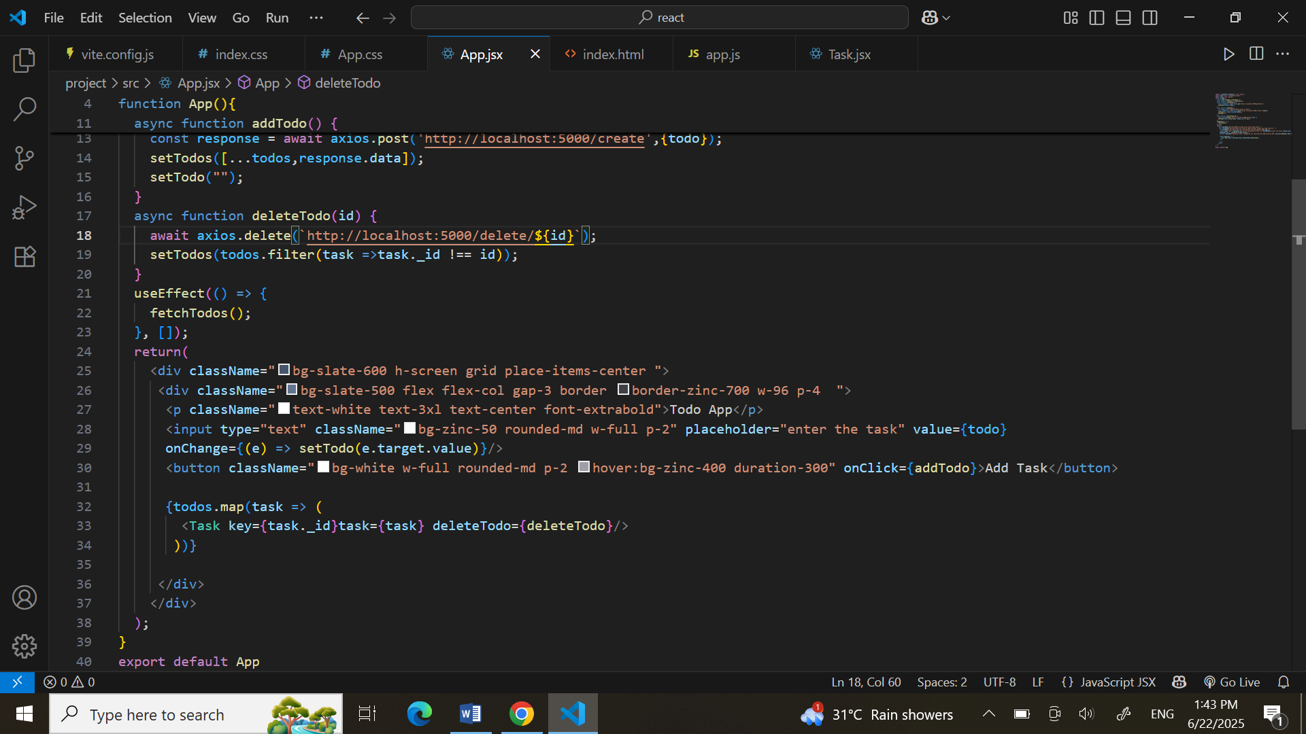

# 

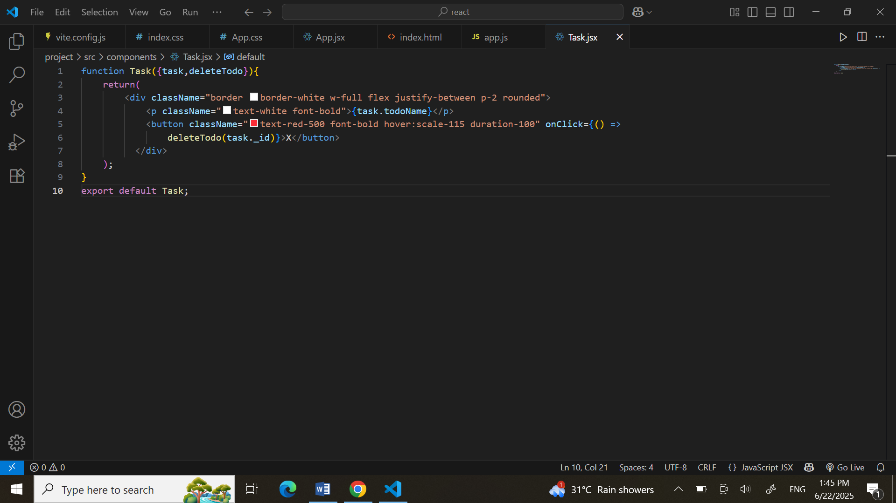

# RESULT

